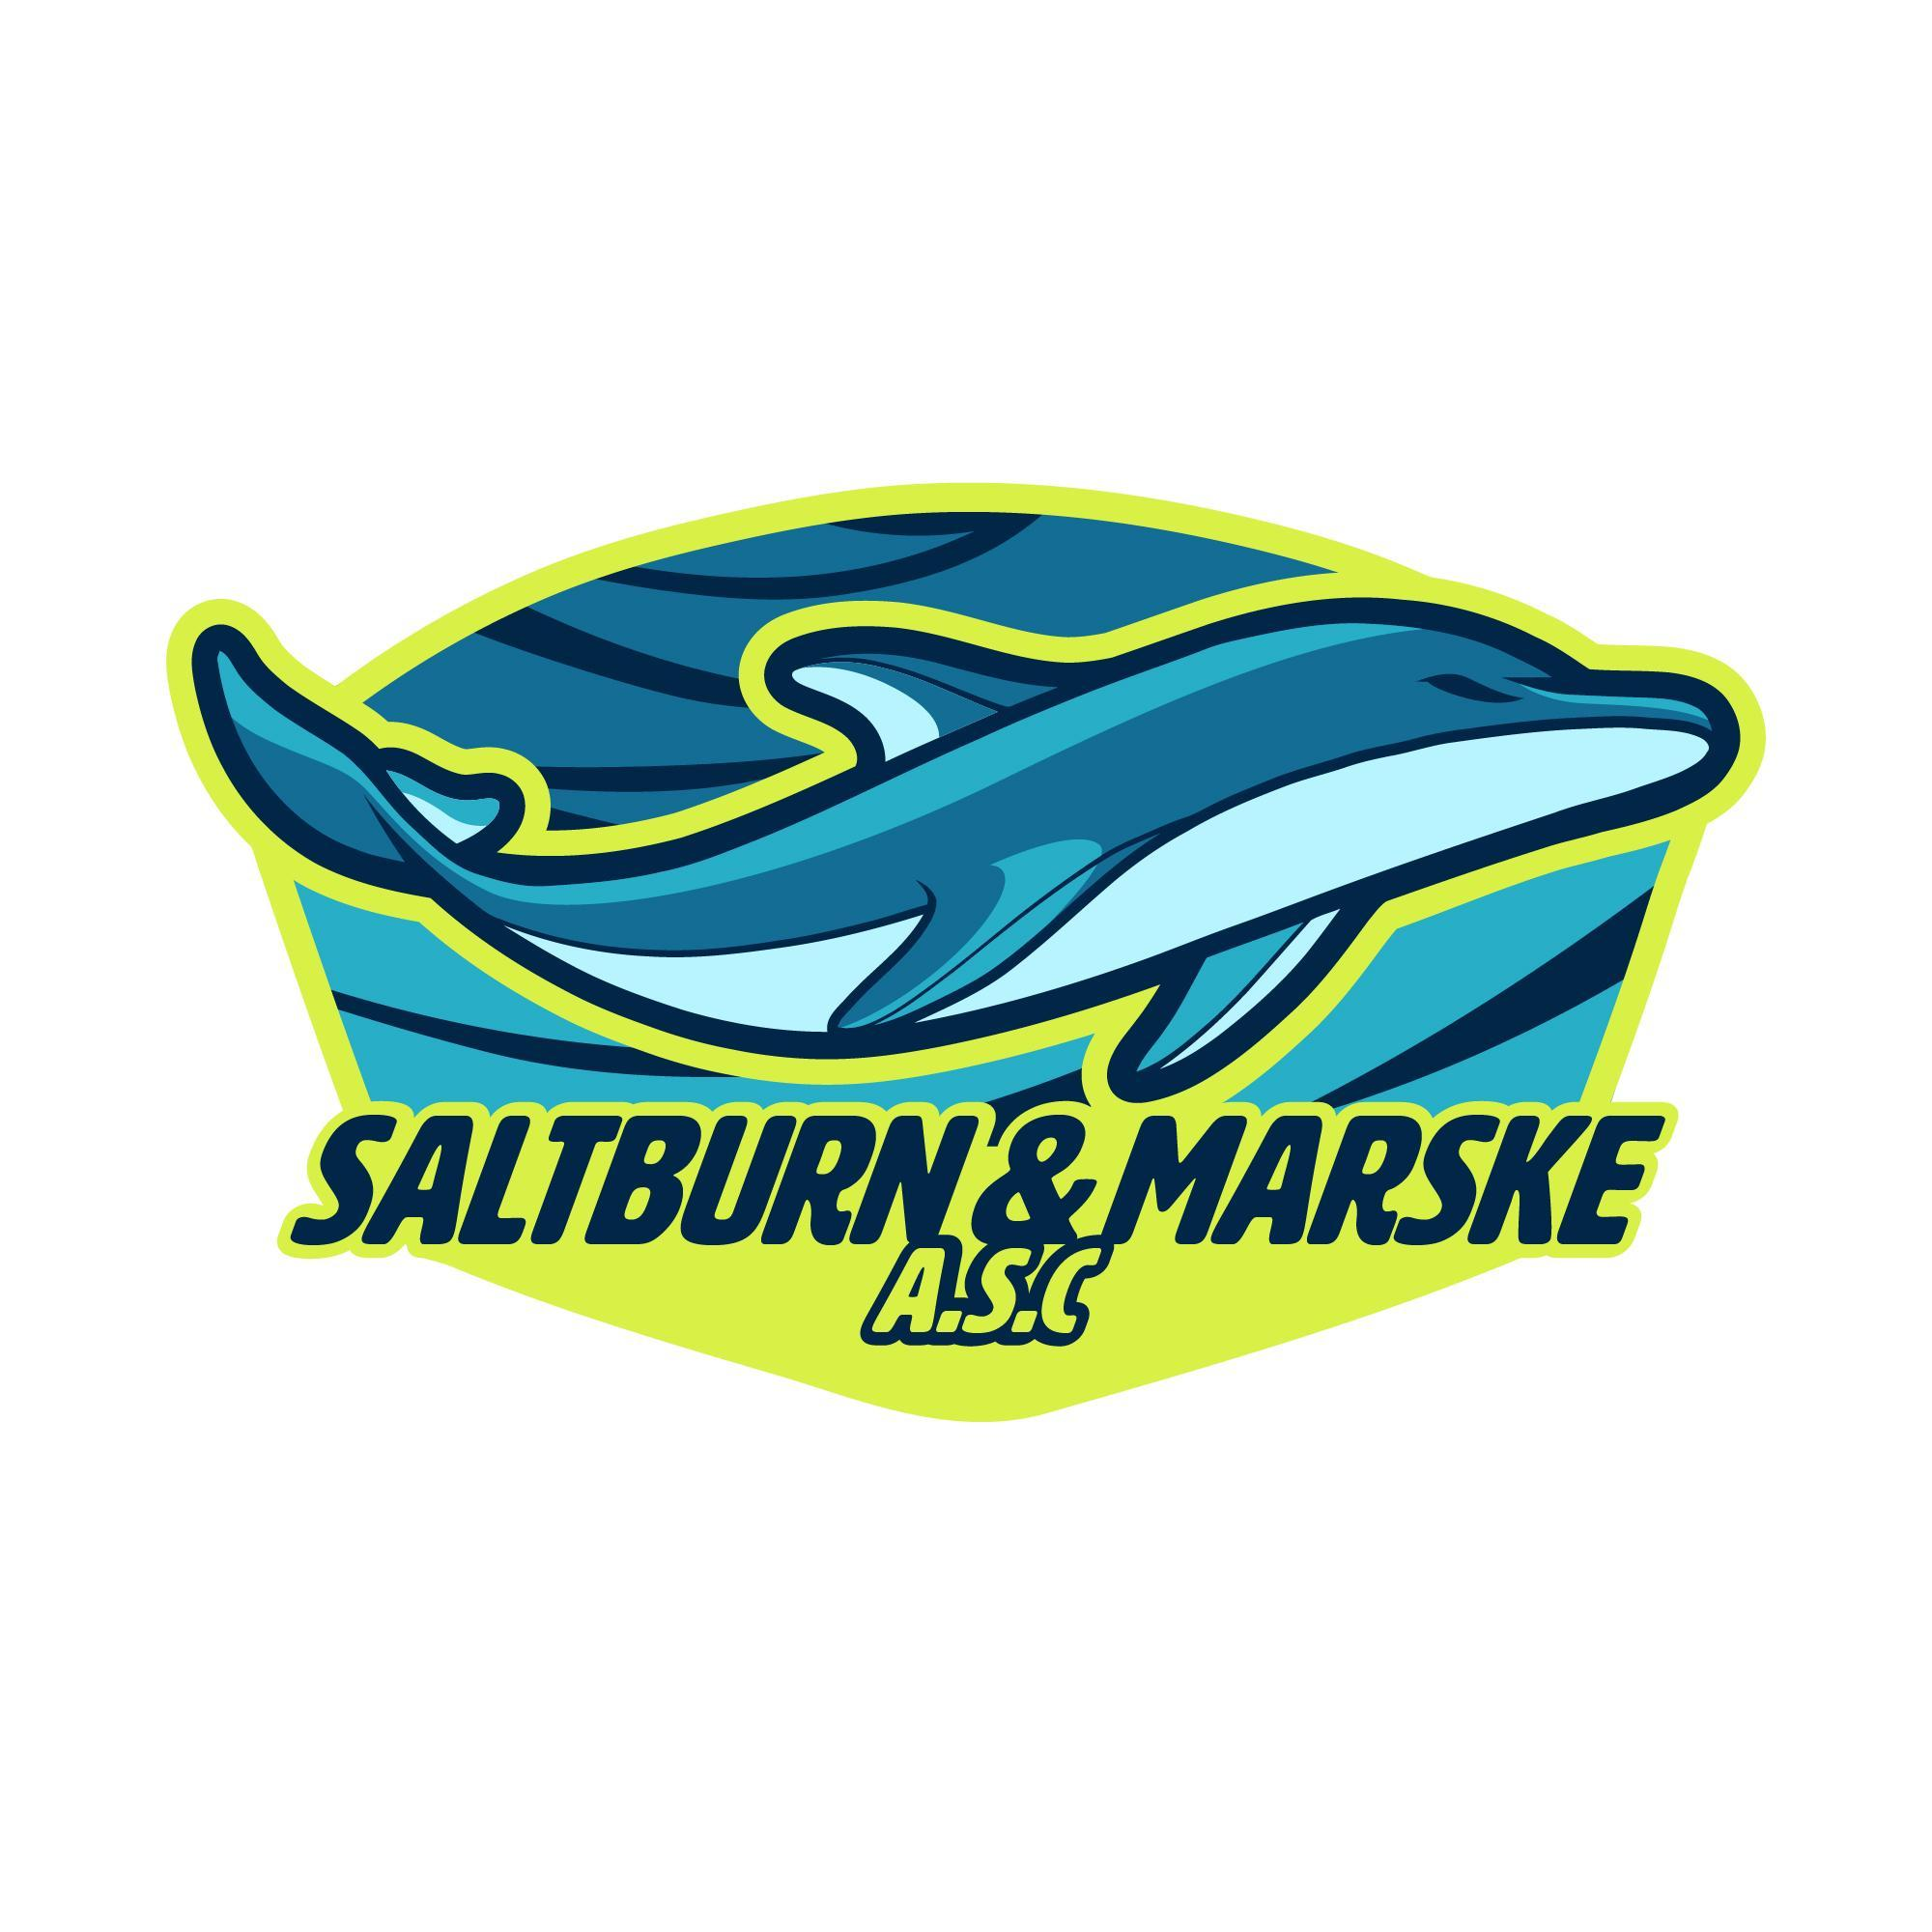
Head Coach – Saltburn & Marske ASC Swim Club
Location: Saltburn Swimming Pool / Redcar Swimming Pool
Governing Body: Swim England
Role Type: Voluntary
Start Date: March 2026 (negotiable)

Saltburn & Marske ASC is a friendly, community-based Swim England–affiliated club seeking a Head Coach to lead our coaching programme and support the development of swimmers in a positive, inclusive environment. The club has swimmers achieving county and regional times as well as regularly competing in galas and the annual Moors League series alongside other local clubs in the region.

This role would suit an enthusiastic coach who enjoys working at grassroots level and helping swimmers progress while fostering a love for the sport.

Key Responsibilities
- Lead and develop the club's coaching strategy and training programmes across all squads
- Support swimmer development across ability levels
- Ensure sessions align with Swim England guidelines and club pathways
- Provide leadership and guidance to assistant coaches and volunteers
- Work collaboratively with the club committee and welfare officer
- Promote a positive, inclusive, and supportive club culture
About You
- Swim England Level 2 Coaching Qualification (or working towards)
- Current DBS check (or willing to obtain one)
- Institute of Swimming Safeguarding and First Aid certificates (or willingness to complete)
- Experience coaching within a club environment
- Reliable, approachable, and passionate about swimmer development
What We Offer
- A supportive committee and welcoming club environment
- Flexibility around training hours and commitments (training days are Monday, Wednesday, Saturday and Sunday across three squads)
- A team of L1 coaches to support session delivery
- Opportunity to shape the future direction of a small Swim England club
- Coaching development
If you’re passionate about swimming and want to give back to a local club, we would love to hear from you.

Please contact:
Maria Sleight - chair.smasc@gmail.com

