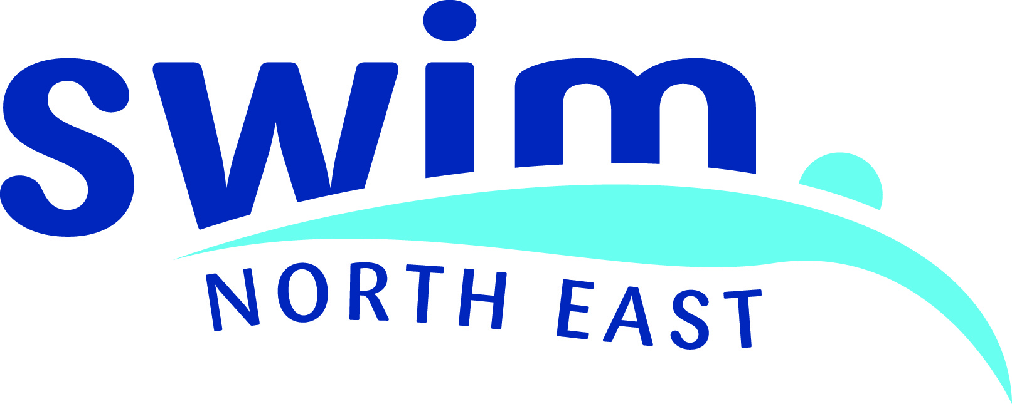
ASA North East Region Website Events Calendar
Request for event to be added to the calendar
Please complete all information in the table below for your event and return via email to swimnortheast@swimming.org or in the post to the regional office at the address below. We will endeavour to get it added to the calendar within 24 hours of receiving a completed form.
Title of event:
Licence Number:
Type of event (please delete): | Swimming/Diving/Water Polo/Synchro/Masters/Para-Swimming
Date(s) of the event:
Location of event:
Contact details for the event:
Website for event (if applicable):
Extra information about the event that you would like to go in the calendar:

If you have any questions about this form or the calendar, please contact the regional office:
ASA North Region, 13 Horsemarket, Darlington, DL1 5PW call 01325 481260

