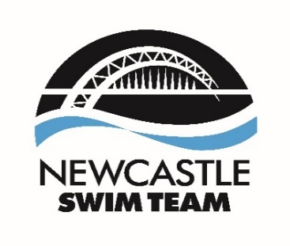
Join the Elite Team at Newcastle Swim Team!

Are you a passionate and dynamic coach looking for an exciting opportunity to make a significant impact? Newcastle Swim Team, the leading SwimMark accredited club in Northumberland and Durham, is seeking a highly motivated Level 2 coach to join our vibrant Masters' Squad.

About Us
With over 270 members, our club boasts a diverse range of swimmers, from entry-level Dolphins to our flourishing Masters’ Squad. Based in the heart of Newcastle upon Tyne, we have a stellar track record, having secured over 29 medals at each of the last two British Summer Championships. Since 2015, our swimmers have achieved remarkable success, earning medals at prestigious events such as the World Junior Championships, European Junior Championships, Commonwealth Youth Games, European Youth Olympics Festival, and Olympic trials.

The Role
We are looking to employ an inspiring and dedicated coach to work with our highly popular Masters' Squad for 5 hours per week. This squad has seen tremendous growth over the past 18 months and includes both competitive and non-competitive members, with athletes ranging from National level competitors to British Record holders. Your role will involve:

- Inspiring and motivating athletes to reach their full potential
- Collaborating with our coaching team, friendly committee, and volunteers
- Contributing to the continued success and growth of our Masters' Squad

Qualifications and Requirements
The ideal candidate will:
- Be a Swim England Swimming Coach (ASA Level 2) or hold an equivalent qualification
- Be eligible to work in the UK
- Share our commitment to safeguarding and promoting the welfare of children and young people
Why Join Us?
At Newcastle Swim Team, you'll be part of a supportive and enthusiastic community that values excellence and teamwork. You'll have the opportunity to work with some of the best talent in the region and contribute to their ongoing success at national and international levels.

Application Process
Newcastle Swim Team is dedicated to safeguarding and promoting the welfare of children and young people. All offers of appointment are subject to satisfactory references and DBS clearance.

If you're ready to take the plunge and join our award-winning team, we'd love to hear from you!

How to apply
Please send a CV and covering letter explaining why you would be suitable for the role along with all necessary experience and coaching qualifications to admin@newcastleswimteam.co.uk. For an informal discussion prior to applying please email the club Chair, Brian Denholm on chair@newcastleswimteam.co.uk

