The Co-creation of the Future of Coaching Toolkit
February 2025

Contents
 |  | Page
- Introduction and how you can help | ……………………………………………. | 2
- Approach | ……………………………………………. | 2
- Timelines | ……………………………………………. | 3
- Survey | ……………………………………………. | 4-6
- Workshops | ……………………………………………. | 6-8
- Web article | ……………………………………………. | 8-9
- Let us know | ……………………………………………. | 10

- Introduction
In 2025, Swim England will be launching a new coaching strategy.

The Co-Creation of the Future of Coaching will be an ambitious, inspiring strategy which will be developed by the aquatics community.

It aims to value all coaches and coaching, creating better experiences for coaches, participants and clubs, and taking a shared responsibility for coaching and culture change.

Collaboration will be at the heart of the development of the strategy, and we plan to meaningfully engage coaches from all aquatic disciplines, clubs and participants in a process that creates a sense belonging and shared ownership over the future of coaching in aquatics.

How you can help
A huge thank you for already playing a part in raising awareness of the Co-Creation of the Future of Coaching process.

Regional engagement and support in this process is essential. Building on the work completed so far, we have updated this toolkit which we hope will provide further resources to enable you to help raise awareness.

Your support would be appreciated in promoting this work. Please use the assets included in this toolkit on your website, social channels and emails to members – and mention the survey and workshops in any meetings or network groups you may have between now and the end of April.

Your support is a key element of ensuring as many people as possible share their views on such an important topic.

- Approach
Swim England will be carrying out an extensive consultation with coaches, participants, parents, clubs and coaching stakeholders up until the end of April.

This has been done on a staggered basis, with coaches receiving the survey first on Wednesday 22 January. Clubs were sent the survey on Wednesday 5 February in Club News with participants and parents emailed a copy in Member News on Wednesday 12 February.

Alongside this, workshops will be held across the country for those who are impacted by coaching to put forward their views and opinions and discuss ideas. Full details are included in the timelines section below.

Following the surveys and workshops, individual interviews will also be carried out by members of the Swim England team, while the Online Community will also be consulted and asked for their thoughts.

All the feedback received will be used to help shape the new coaching strategy.

- Timelines
Below is a summary of the timelines:

Date | Activity
Wednesday 22 January | Survey emailed to coaches and article published on Swim England website and across its social channels
Wednesday 5 February | Survey emailed to clubs
Wednesday 12 February | Survey emailed to athletes and parents
Throughout March | Workshops are taking place at eight venues across the country. These are:  - Wednesday 5 March: Days Inn by Wyndham Wetherby, Junction 46 A1 M Kirk Deighton, Wetherby, West Yorkshire  - Thursday 6 March: Macdonald Hotel and Resorts, The Tickled Trout, Preston New Road, Samlesbury, Preston PR5 0UJ  - Wednesday 12 March: Pitch and Pool Room, SportPark, 3 Oakwood Drive, Loughborough University LE11 3QF  - Thursday 13 March: Mercure Birmingham West Hotel, Birmingham Road, M5 Jct 1, West Bromwich, B70 6TU  - Wednesday 19 March: Hyatt Regency, Hyatt House London Stratford, 10A Chestnut Plaza, Montfichet Road, Westfield, Stratford City, London E20 1GL  - Thursday 20 March: Holiday Inn Lakeview, Bridge Rd, Impington, Cambridge CB24 9PH  - Wednesday 26 March: Holiday Inn, Deane Gate Ave, Taunton TA1 2UA  - Thursday 27 March: Holiday Inn, Egerton Rd, Guildford GU2 7XZ  Two sessions will be held on each day – from 1.30pm to 4pm and 5.30pm to 8pm.
Wednesday 30 April | Last day to submit responses to survey

- Survey

As mentioned, we have emailed coaches, participants, parents and clubs with a survey for them share their views on coaching.

The survey will take around 10-15 minutes to complete and will be open until the end of April.

The links to the surveys are:
Coaches: bit.ly/SEcoachsurvey
Participants and parents: bit.ly/SEparticipantsurvey

The club survey has been sent direct to clubs with one person being asked to collate the views of the committee.

We’re keen to hear from coaches across all aquatic disciplines and at every level. Whether they have just started coaching, work with talent athletes or at a grassroots level, the feedback received will be invaluable.

In addition, the views and opinions and from participants on what qualities they value in a coach and what makes a great coaching environment are also vitally important.

Please use the socials graphics below and the suggested social posts between now and the end of April to continue to raise awareness of the surveys. These are also available to download by clicking here.

In addition, there is new suggested copy for your newsletters to help continue the promotion of the survey and / or workshops. Please adapt this as necessary. Your ongoing support will be crucial to the overall success of this project.

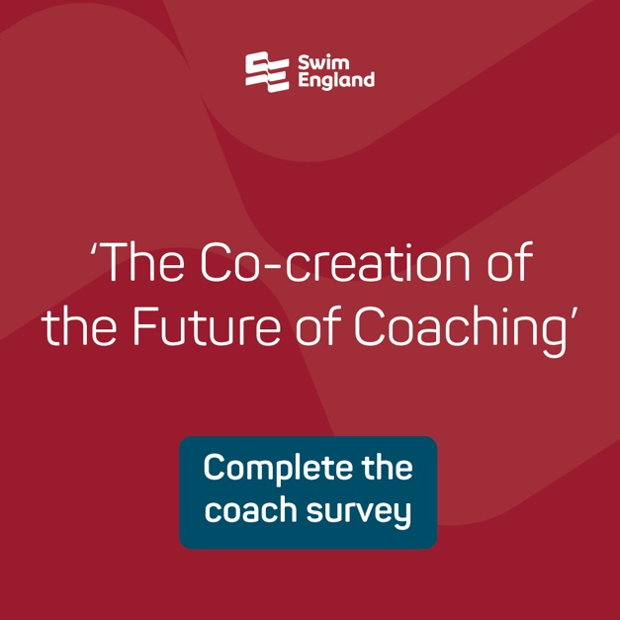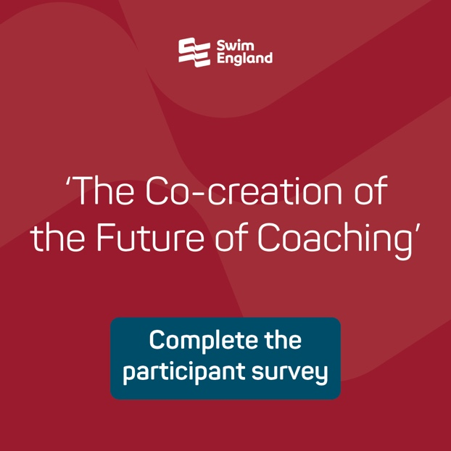

Suggested social posts
Post one
It’s question time…

Swim England is seeking the views of coaches and participants to help shape a new coaching strategy

Share your views as part of the Co-creation of the Future of Coaching process

Coaches ▶️ bit.ly/SEcoachsurvey
Participants ▶️ bit.ly/SEparticipantsurvey

Post two (to be used Wednesday 16 April)
The clock is ticking ⏰

There’s only 2⃣ weeks for coaches and participants to have their say on the Co-Creation of the Future of Coaching

Complete the survey and help shape a new coaching strategy 🖊️

Coaches ▶️ bit.ly/SEcoachsurvey
Participants ▶️ bit.ly/SEparticipantsurvey
Suggested content for email newsletter (survey only)

A huge thank you to everyone who has taken time to complete the Co-creation of the Future of Coaching survey.

There is still time to get involved in the process if you haven’t already done so – and Swim England is keen to hear from coaches at all levels across all aquatic disciplines.

Participants can also share their views on what qualities they value in a coach and what makes a great coaching environment.

The views and opinions will help shape a new coaching strategy to be published by Swim England later this year.

Have your say by clicking on the survey link which applies to you:
Coaches: bit.ly/SEcoachsurvey
Participants and parents: bit.ly/SEparticipantsurvey

Suggested content for email newsletter (survey and workshops only)
A huge thank you to everyone who has taken time to complete the Co-creation of the Future of Coaching survey.

There is still time to get involved in the process if you haven’t already done so – and Swim England are keen to hear from coaches at all levels across all aquatic disciplines.

Participants can also share their views on what qualities they value in a coach and what makes a great coaching environment.

The views and opinions will help shape a new coaching strategy to be published by Swim England later this year.

Have your say by clicking on the survey links:
Coaches: bit.ly/SEcoachsurvey
Participants and parents: bit.ly/SEparticipantsurvey

Alternatively, coaches can also book a place on one of 16 workshops being held at eight venues across the country during March.

Find out more and book your place by clicking here (link to https://forms.swimming.org/coach-strategy-workshop/)

- Workshops
Face-to-face workshops for coaches to attend will be held across the country during March, with the sessions taking place at two times – 1.30pm to 4pm and 5.30pm to 8pm – at each venue. The details are:

North East
Wednesday 5 March: Days Inn by Wyndham Wetherby, Junction 46 A1 M Kirk Deighton, Wetherby, West Yorkshire, United Kingdom LS22

North West
Thursday 6 March: Macdonald Hotel and Resorts, The Tickled Trout, Preston New Road, Samlesbury, Preston PR5 0UJ

East Midlands
Wednesday 12 March: Pitch and Pool Room, SportPark, 3 Oakwood Drive, Loughborough University LE11 3QF

West Midlands
Thursday 13 March: Mercure Birmingham West Hotel, Birmingham Road, M5 Jct 1, West Bromwich, B70 6TU

London
Wednesday 19 March: Hyatt Regency, Hyatt House London Stratford, 10A Chestnut Plaza, Montfichet Road, Westfield, Stratford City, London E20 1GL

East
Thursday 20 March: Holiday Inn Lakeview, Bridge Rd, Impington, Cambridge CB24 9PH

South West
Wednesday 26 March: Holiday Inn, Deane Gate Ave, Taunton TA1 2UA

South East
Thursday 27 March: Holiday Inn, Egerton Rd, Guildford GU2 7XZ

The workshops will run alongside the surveys and discussions will be held around some of the points raised, based on analysis of the data. Ideas and opinions from all attendees will be taken on board and used to help form the Co-creation of the Future of Coaching.

Please help us to promote the workshops by using the suggested social post below and either (or both) of the graphics. One has been created specifically for your region if you’d prefer to just use that.

The link for coaches to book a space on any of the workshops is: https://forms.swimming.org/coach-strategy-workshop/

Suggested social posts
Copy and paste the below posts to include the emojis on the social posts. Try to attach one of the social media graphics and link to the booking form when posting.

Post one (to be used on Wednesday 26 February)
Have you booked your place? 🤔

Coaches, there’s only one week until the Co-Creation of the Future of Coaching workshops begin so don’t miss this exciting opportunity to have your say and be part of a shared vision ⬇️
Post two (use two days before your region is due to host a workshop with the region-specific graphic)
🚨 Only 4⃣8⃣ hours to go! 🚨

The (INSERT REGION HERE) is hosting a Swim England Co-Creation of the Future of Coaching workshop at (INSERT VENUE HERE) on (INSERT DATE HERE).

Coaches can help shape the future of coaching in aquatics by booking a place on one of two sessions taking place

Find out more ⬇️
Swim England social handles
Please tag us in your posts using the following handles:

- X: @Swim_England
- Facebook: @SwimEngland
- Instagram: @swimengland
- LinkedIn: Use the @ symbol and start typing Swim England.
Suggested social graphics
Below are examples of the graphics which can be used to help promote the workshops. The full range of graphics can be downloaded by clicking here.

Generic graphics
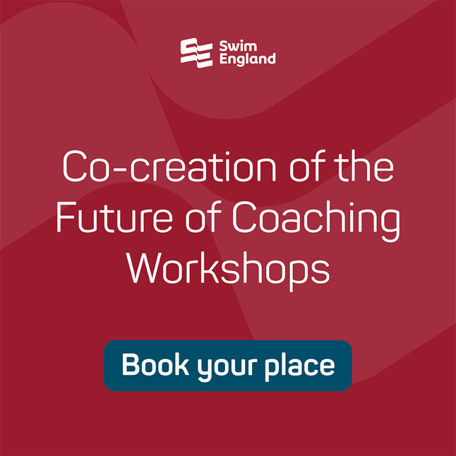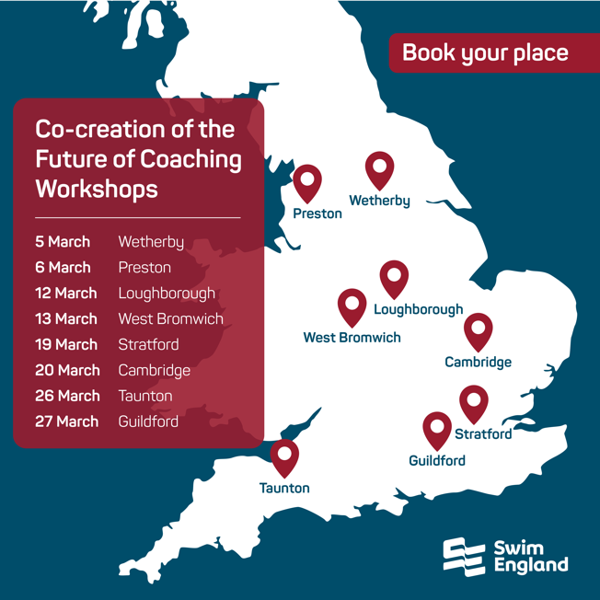

Examples of regional specific graphics
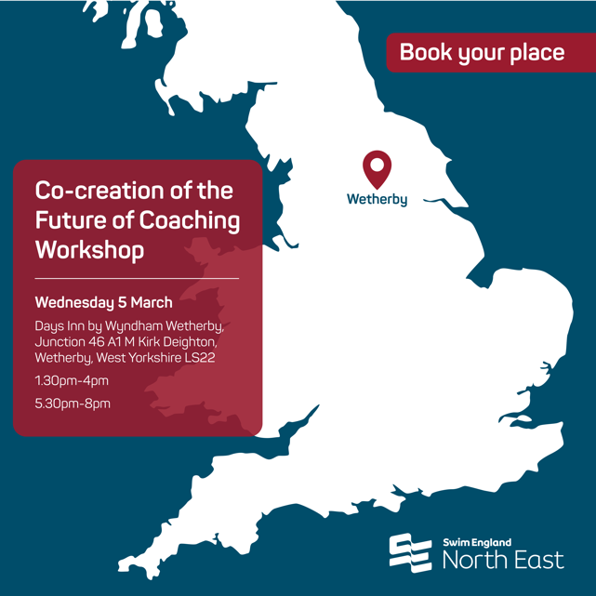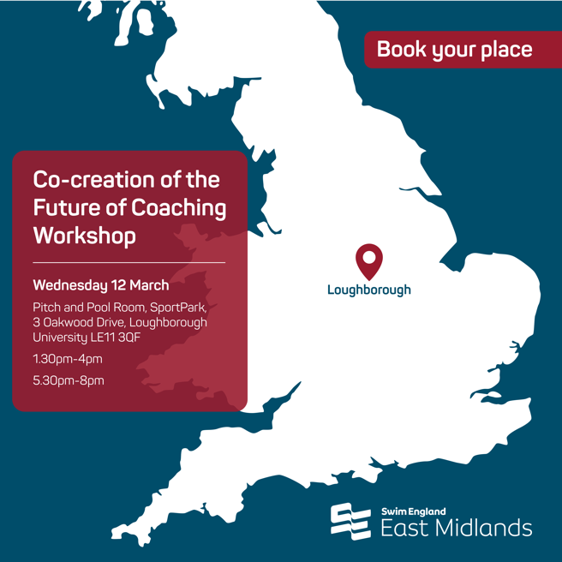

- Article
The following article has been on the Swim England website.

Please feel free to use it on your website, if you haven’t already done so, and share with your members to help raise awareness of the new coaching strategy and the consultation around it.

This version now includes the links to the coach plus participants and parents’ surveys.
Swim England members given invaluable opportunity to help shape new coaching strategy
Coaches, participants, parents and clubs are being given an invaluable opportunity to play an active role in shaping the future of coaching in aquatics.
Swim England is to launch a new coaching strategy in 2025 and the views of the aquatics community will be at its heart.
The Co-creation of the Future of Coaching process aims to reconnect and redefine the purpose of coaching, build on existing good practice and create a thriving and flourishing coaching culture.
A survey is being distributed to more than 129,000 Swim England members over the next few weeks, while a series of nationwide workshops will also be held for coaches to explore, reflect, discuss and develop ideas.
Complete the surveys
Coaches: bit.ly/SEcoachsurvey
Participants and parents: bit.ly/SEparticipantsurvey
The Co-creation of the Future of Coaching will aim to achieve better experiences for coaches, clubs and participants.
Craig McCulloch, Swim England head of coaching, said the insight gathered from the survey and workshops would help to lay the foundations of the new strategy.
“This is a key chance to be part of a shared vision which shapes the future of coaching across all aquatic sports,” said Craig.
“The Listening Report highlighted a number of negative experiences in coaching and we’re committed to ensuring this doesn’t happen in the future.
“However, we can’t do this on our own.
“The Co-creation of the Future of Coaching is a process that will create a sense of belonging and shared ownership. It will be a strategy for coaches, informed by coaches and everyone they work closely with.
“By sharing your views, you’ll be helping to ensure that we foster a culture that is supportive and inclusive, where coaches are equipped to lead by example and inspire everyone.”
The survey will ask coaches to share their views on the fundamental purpose of coaching, what is good coaching, the challenges they face in their role and what they would like to see from coach development in the future.
Participants and parents will also be asked what qualities they value in a coach and how they feel when training.
The survey will be open until the end of April, while the workshops will take place on the following dates throughout March, with sessions taking place at two times – 1.30pm to 4pm and 5.30pm to 8pm – at each venue:
- Wednesday 5 March: Days Inn by Wyndham Wetherby, Junction 46 A1 (M) Kirk Deighton, Wetherby, West Yorkshire, LS22 5GT
- Thursday 6 March: Macdonald Hotel and Resorts, The Tickled Trout, Preston New Road, Samlesbury, Preston PR5 0UJ
- Wednesday 12 March: Pitch and Pool Room, SportPark, 3 Oakwood Drive, Loughborough University LE11 3QF
- Thursday 13 March: Mercure Birmingham West Hotel, Birmingham Road, M5 Jct 1, West Bromwich, B70 6TU
- Wednesday 19 March: Hyatt Regency, Hyatt House London Stratford, 10A Chestnut Plaza, Montfichet Road, Westfield, Stratford City, London E20 1GL
- Thursday 20 March: Holiday Inn Lakeview, Bridge Rd, Impington, Cambridge CB24 9PH
- Wednesday 26 March: Holiday Inn, Deane Gate Ave, Taunton TA1 2UA
- Thursday 27 March: Holiday Inn, Egerton Rd, Guildford GU2 7XZ
Places can be booked on the workshops by clicking here.
Craig added: “This is an exciting process which will drive significant change and create a roadmap for the future which the coaching community can be proud of.”
If you have not received a copy of the survey and wish to submit your views, please email coaching@swimming.org
- Let us know
Please keep us updated on your plans to help promote the survey and workshops. We’d love to hear when you’re planning to publish something – whether that be on social or through an email newsletter – and the reach of your audiences. And don’t forget to tag us in your social posts.

If you need anything else to help support the promotion of the Co-creation of the Future of Coaching, please get in touch.

We’d also love to hear your feedback on this toolkit and how we can make further improvements to future toolkits.

Please email communications@swimming.org with details of your planned promotion, any comments or if you have any further questions.

Thank you.

