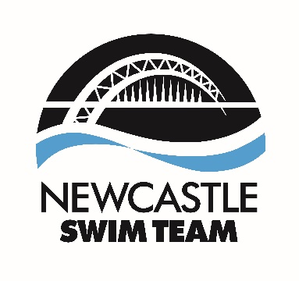

Job Title: Lead Strength and Conditioning Coach (Land Coach)
Squads Responsible: Four Squads (Performance Squad, National Squad, Regional Squad, County Squad)
Location: Byker Swimming Pool & Newcastle University Sports Centre
Core Coaching Hours: 8 – 10 per week
Core Coaching Days: Wednesday evening, Friday evening, Sunday lunchtime
Employment Status: Flexible
Remuneration: Negotiable
Role Overview/Background:
The successful candidate is to provide strength and conditioning support throughout Newcastle Swim Team (NST). The role also includes being able on occasions to support the swim coaches with pre-pool routines and attend certain competition meets throughout the year.
Reporting Relationships – Head Coach
Head Coach – Matthew Allison Assistant Head Coach: James Shackleton
Job Description:
The S&C programme at Newcastle Swim Team is in place to support each swimmer through their physical development journey and is tailored to meet the needs of all stages of development, from age group to performance level. The appointed S&C coach will be required to work collaboratively with the Swim coaches as part of a wider support team. You will lead, plan and deliver to all age group squads at the club, in line with the clubs Long Term Athletic Development (LTAD) structure. The role is suitable for a coach, who is motived, enthusiastic and who is willing to improve and challenge the programme each season. The coach must be able to work with young people.
Key Tasks:
- Coaching all stages of development while adhering to the clubs’ principles of LTAD and its philosophy.
- Planning and delivering session plans to all squads.
- Monitoring attendance for all sessions delivered – reporting back to the squad coach.
- Physical competency and maturation monitoring of athletes once per training cycle.
- Communicating with all squad coaches regarding each swimmers’ individual development.

Professional Standards:
- To provide a committed and professional approach towards coaching.
- Follow the Swim England Child Safeguarding Policy and Procedures (Wavepower) and all Health and Safety Procedures.
- Adhere to the Newcastle Swim Team Coach Code of Conduct and Swim England Code of Ethics.
- Follow and promote the vision, values and policies of Newcastle Swim Team ASC internally and externally.
- Be aware and understand the facility Emergency Action Plan (EAP) and Normal Operating Procedures (NOP) of the facilities.
- Undertake any other tasks appropriate to this level of responsibility.
Person Specification:
Qualifications and key skills, qualities experience and attributes.
- UKSCA Accredited Coach or working towards whilst in this position.
- 1-2 years working within the S&C industry.
- Knowledge of periodisation along with understanding LTAD pathway.
- CIMSPA endorsed Gym instructor or L3 personal trainer (essential)
- BSc in Sports Science or a related field (desirable).
- First Aid at Work (or availability to attend a course prior to start date)
- An excellent understanding of the principles of land training.
- Excellent work ethic, who is able to problem solve when needed.
- A reliable and dependable individual.
This post is subject to satisfactory DBS check, references and completion of a Swim England Safeguarding Course.
For an information discussion regarding the role please contact Ross Drummond: rossdrummond@newcastleswimteam.co.uk
Application: To Apply please forward your CV and covering letter to the following: Julie Row, Club Administrator – admin@newcastleswimteam.co.uk
- Applications closes: Friday 21st March 2025
- Interviews will take place in person w/c 3rd April 2025
- The post start date is 5th May 2025

