

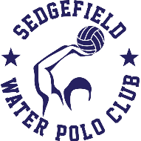
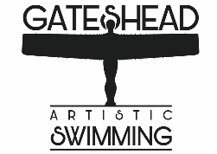
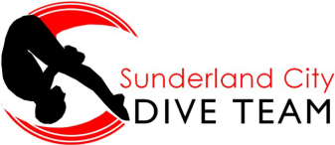

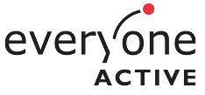
FESTIVAL OF AQUATICS

Can you swim and would you like to try three exciting new sports in the water? The Northumberland and Durham Swimming Association are holding a Festival of Aquatics in your area to give you the chance to try Artistic Swimming, Diving and Water Polo. There will be sessions both in the pool and on land for all three sports throughout a fun packed morning!

You must have reached Stage 6 of Swim England Learn to Swim to take part, and places are open to all children up to and including the age of 16. A swim test will be done on the day to confirm competence.

When: Saturday 6th June 2026.
Time: 9am – 1pm (registration from 8:30am).
Where: Sunderland Aquatics Centre, Sunderland, SR5 1SU.
Cost: £10 per person (includes a packed lunch).

Scan the QR code to book your place!

